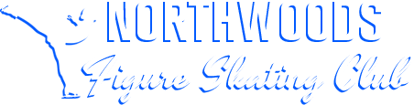
Heggie’s Pizza Fundraiser 2024
The Heggie’s Pizza Fundraiser is back for our 2024-2025 Season. Please see the bullet points below. In order to keep our fees as low as possible, we need to fund-raise. Thank you for your commitment to the Northwoods Figure Skating Club and Happy Selling!
- If you are a family NEW to NFSC this session (started Nov. 3 or 4) you are not required to fundraise, but we appreciate any assistance!

- There is a $100 Fundraiser Buyout option for those not wishing to sell pizza. This is per skater if a family has multiple skaters.

- If not doing the buy-out, ALL skaters are required to sell pizza. There is a minimum sale of 15 pizzas per skater. IF you have multiple skaters in your family, the minimum sale per family is 20 pizzas.
- All skaters that sell at least 20 pizzas will be entered in a drawing for a Northwoods Figure Skating PRIZE!
- The TOP seller will receive a $75 punch card!
- You can start selling now.

- When you sell, please only accept cash or a check made out to YOU. When you turn in your order form, we will only accept cash or a check made out from you to NFSC. Sales forms AND the money (cash or check made out to NFSC) must be turned in no later than Dec. 1st in Rice Lake or Dec. 2nd in Cumberland. Your order WILL NOT be placed without the order form and the money. If that occurs, you will be responsible for paying the $100 buyout.
- Pizzas will be distributed on Monday, December 16th at the Cumberland Hockey Rink (500 8th Avenue Cumberland, WI 54829). You will be responsible for picking up your pizzas between 5:30-8:00pm that night.

- Thank you!

